SYNTRY FACE RECOGNITION SYSTEM DOCUMENTATION

ALI MADARI

Table of Contents
SyntryRepository.cs – Database Access 7
Purpose 7
Class Structure 7
Connection Handling 7
Constructor 7
Creating a connection 7
Checking if a User has a Face Data 8
Purpose 8
SQL Query 8
Upsert User (Insert or Update) 8
Purpose 8
SQL Query 8
Log Attendance 8
Purpose 9
SQL Query 9
Set User Active / Inactive 9
Purpose 9
SQL Query ( Active : 1 and Disabled : 0) 9
Delete User 9
Purpose 10
SQL Query 10
Get Username Helper 10
Purpose 10
SQL Query 10
Search Users by Name 10
Purpose 10
SQL Query 10
Program.cs – Application Entry Point 10
Purpose 11
Global Variables 11
Purpose 11
Purpose 11
Purpose 11
Main Method 11
Read Command Line Port – Step 1 11
Purpose 11
Configure Logging – Step 2 11
Create Host Builder– Step 3 12
Load Configuration– Step 4 12
Override Port if CLU Argument Exists 12
Dependency Injection– Step 5 13
Load Configuration Values from appsettings.json 13
Register Database Repository 13
Enable Serilog for Host– Step 6 13
Build the Host– Step 7 13
Run the Server– Step 8 13
Error Handling and Cleaning Logs 14
ServerHost.cs – Core Runtime Orchestrator 15
Purpose 15
Ready Signal 15
Logger 15
Configuration Access 16
MAIN METHOD 16
Initialize AI Models – Step 1 16
Load Face Embeddings – Step 2 16
Start Background Synchronization – Step 3 17
Start WebSocket Server – Step 4 17
Notify System that Server is Ready – Step 5 17
Error Handling 17
WebSocketLoader.cs – Device Communication & Processing Engine 18
Purpose 18
Device Sessions 18
Device Serial Number Mapping 18
Admin Sessions 19
Pending Face Enrollments 19
PendingEnrollment Structure 19
AI Scan Queue 20
AI Worker Threads 20
Starting the WebSocket Server 20
Server Configuration 20
Connection and Disconnection Handlers 20
Message Handling 20
Command Dispatcher 21
Device Registration 21
Face Enrolment Workflow Enrolment Steps 22
Handling Device Logs 22
Scan Detection 22
AI Scan Processing 22
AI Recognition 22
Access Decision Logic 23
Live Scan Feed for Admins 23
Cleaning Device Logs 23
FaceRecognition.cs (FaceMatch) — AI Face Recognition Engine 24
Purpose 24
User Information Structure 24
AI Threshold Configuration 24
FaceDetectorYN 25
FaceRecognizerSF 25
Model Initialization 25
Loading Face Embeddings 25
SQL Query 25
Two-Phase Loading Strategy 26
Phase 1 — Fast Database Read 26
Phase 2 – AI processing 26
Result Stored in RAM 26
Matching a Face 26
Face Feature Extraction 26
Liveness Detection 27
Face Matching Algorithm 27
Match Result Object 27
Adding a New User to Memory 27
Removing a User 28
Database Synchronization 28
Antispoofing.cs — Liveness Detection Module 29
Purpose: 29
Core Mode 29
Model Initialization 29
Prediction Process 29
Processing Steps 30
Crop Face Region – Step 1 30
Image Preprocessing – Step 2 30
Neural Network Inference – Step 3 30
Softmax Normalization – Step 4 30
Output Result 30
Thread Safety 30
ScanJob.cs — Scan Task Structure 31
Purpose 31
Class Definition 31
Fields 31
Device Serial Number 31
Face Image 31
WebSocket Session 31
Timestamp 31
ConsoleInteractor.cs — Console Interaction Utility 32
Purpose 32
Key Feature 32
Ask a Question 32
Timeout Handling 32
Yes / No Helper 32
Thread Safety 32
WebSocketService.cs — Windows Service Wrapper 33
Purpose 33
Linux Server Implementation 33
Device Settings 34
System: 34
Device Setup: 34
Advanced Setup 35
Access: 36
Shift: 37

SyntryRepository.cs – Database Access

Purpose
Is responsible for all database operation related to users and attendance. It acts a database access between the application and the PostgreSQL Server Database. All database logic is mostly centralized inside this class.

Class Structure
public class SynteryRepository
This class will contain all methods used to interact with the database.
Key features:
- asynchronous database calls
- connection encapsulation
- attendance logging
- user management

Connection Handling
private readonly string _connString;
Stores the PostgreSQL Server connection string passed from the main application.

Constructor
public SynteryRepository(string connString)
{
_connString = connString;
}
The constructor initializes the repository with the database connection string.

Creating a connection
private IDbConnection CreateConnection() => new SqlConnection(_connString);
This helper method creates a new SQL connection whenever a database operation is executed.
Connections are opened inside each method and disposed automatically using the keyword “using”

Checking if a User has a Face Data
public async Task<bool> HasFaceDataAsync(int enrollId)

Purpose
Checks whether a user already has facial data stored in the database. preventing duplicate enrolment.

SQL Query
SELECT COUNT(1)
FROM tblusers_face
WHERE enrollid = @Id AND backupnum = 50
Returns:
true → user already has face
false → no face registered

Upsert User (Insert or Update)
public async Task UpsertUserAsync(int enrollId, string name, int backupNum, int isAdmin, string? record)

Purpose
Adds a new user or updates an existing user.
INSERT if user does not exist
UPDATE if user already exists

SQL Query
MERGE tblusers_face AS target
USING (SELECT @Id AS enrollid, @Num AS backupnum) AS source
Returns:
If User Exists Update:
Username , admin ,record (face template) , regdattime , isactive
If User Does Not Exist:
Insert a new record

Log Attendance
public async Task LogAttendanceAsync(int? enrollId, string deviceSn, DateTime time, double? distance)

Purpose
Stores attendance events given by face scans.

SQL Query

Preventing Double Scan – Step 1
SELECT TOP 1 attendattime
FROM tblattendance_face
WHERE enrollid = @EnrollId
ORDER BY attendattime DESC
This retrieves the user's last scan time.

Anti Double-Scan Logic
if ((time - lastScanTime).TotalSeconds < 20)
If the same user scans again within 20 seconds, the scan is ignored preventing duplicate scans.

Insert Attendance Record – Step 2
INSERT INTO tblattendance_face (enrollid, device, attendattime)
VALUES (@EnrollId, @Device, @Time)";
Stores the Fields Enroll id, Device Serial Number and timestamp of the scan into Attendance
Fetch Username – Step 3 (For Future API Implementation as Instructed)
SELECT username FROM tblusers_face
Grabs the username from the database

Set User Active / Inactive
public async Task SetUserActiveAsync(int enrollId, bool isActive)

Purpose
Enable or disable a user controlling whether a user can access the system.

SQL Query ( Active : 1 and Disabled : 0)
UPDATE tblusers_face
SET isactive = @Active
WHERE enrollid = @Id

Delete User
public async Task DeleteUserAsync(int enrollId)

Purpose
Completely removes a user from the database.

SQL Query
DELETE FROM tblusers_face
WHERE enrollid = @Id
Removing all authentication types related to that user.

Get Username Helper
public string? GetUserName(int enrollId)

Purpose
Retrieve the username using an enrollId.

SQL Query
SELECT TOP 1 username
FROM tblusers_face
WHERE enrollid = @Id
Used by other components to get username of a user.

Search Users by Name
public static async Task<List<(int EnrollId, string UserName, int IsActive)>> SearchUsersByNameAsync

Purpose
Allows admin UI to search users by Name.

SQL Query
@"SELECT enrollid, username, isactive
FROM tblusers_face
WHERE username ILIKE @name
ORDER BY username",
Get Users that are alike

Program.cs – Application Entry Point
Is the main entry point of the server application

Purpose
It has multiple functions such as:
- Initializing logging
- Loading configuration
- Setting up dependency injection
- Starting the background services
- Launching the WebSocket server

Global Variables
public static LoggingLevelSwitch ConsoleSwitch = new(LogEventLevel.Information);

Purpose
allows changing console log levels dynamically. ( Default : Information )
Global Connection String
public static string ConnectionString { get; private set; } = string.Empty;

Purpose
stores the database connection string so it can be accessed by other classes
Server Port
public static int ServerPort { get; private set; }

Purpose
Stores the WebSocket server port loaded from configuration (appsettings.json)

Main Method

Read Command Line Port – Step 1
int? cliPort = null;
if (args.Length > 0 && int.TryParse(args[0], out int p))
cliPort = p;

Purpose
Allows the server port to be overridden from command line

Configure Logging – Step 2
Log.Logger = new LoggerConfiguration()
.WriteTo.Console(levelSwitch: ConsoleSwitch)
.WriteTo.File("logs/syntery-.log", rollingInterval: RollingInterval.Day)
.CreateLogger();
This system uses Serilog Logging System, Two Logging outputs are configured:
- Console Logging
  - WriteTo.Console() [ Logs are displayed in the terminal ]
- File Logging
  - logs/syntery-YYYYMMDD.log [ Log files rotate daily ]

Create Host Builder– Step 3
var host = Host.CreateDefaultBuilder(args)
The .NET Generic Host provides:
- dependency injection
- configuration
- background services
- logging
- lifecycle management

Load Configuration– Step 4
config.AddJsonFile("appsettings.json", optional: false, reloadOnChange: true);
Loads Configuration from appsettings.json
- Server:Port
- ConnectionStrings:Default
- AI:FaceDetection
- AI:FaceRecognition
- AI:AntiSpoof
- Face:MatchThreshold
- Face:LivenessThreshold

Override Port if CLU Argument Exists
config.AddInMemoryCollection(new Dictionary<string, string?>{
{ "Server:Port", cliPort.Value.ToString() }});

Dependency Injection– Step 5
.ConfigureServices((context, services) =>
registers application services

Load Configuration Values from appsettings.json
ConnectionString = context.Configuration.GetConnectionString("Default")!;
ServerPort = context.Configuration.GetValue<int>("Server:Port");

Register Database Repository
services.AddSingleton(new SynteryRepository(ConnectionString));
creates a single shared instance of the repository.
Register ServerHost Background Service
services.AddHostedService<ServerHost>();
This is the service that starts the system, Launching:
ServerHost.ExecuteAsync()
Which:
- Loads AI models
- Loads face embeddings
- Starts the WebSocket server

Enable Serilog for Host– Step 6
.UseSerilog()
Replaces the default .Net Logger with Serilog

Build the Host– Step 7
.Build();
This compiles the configuration and services into a runnable application host

Run the Server– Step 8
await host.RunAsync();
starts the application lifecycle. The host will start the background services and wait for the shutdown signal which is CTRL + C which stops all the services and shuts down the system.

Error Handling and Cleaning Logs
try{
}
catch (Exception ex)
{
Log.Fatal(ex, "Application start-up failed");
}
If the server fails during the startup, a fatal error will be logged.
Log.CloseAndFlush();
Ensures all logs are written before the program exits.

ServerHost.cs – Core Runtime Orchestrator
background service responsible for initializing and running the core components of the system.

Purpose
It performs the following critical tasks:
- Initialize the AI models used for face detection and recognition
- Load face embeddings from the database into memory
- Start a background synchronization process with the database
- Launch the WebSocket server that communicates with face devices
- Signal that the server is ready to accept connections
This class inherits from .NET BackgroundService, meaning it runs continuously as part of the application's host lifecycle.
public class ServerHost : BackgroundService
BackgroundService is a built-in .NET class used to run long-running services inside the Generic Host environment.

Ready Signal
public static readonly TaskCompletionSource<bool> ReadySignal = new();
This is used to notify other components (such as a console UI or monitoring system) that the server has successfully started having two values:
True – Server started successfully
False – Server failed during initialization

Logger
private readonly ILogger<ServerHost> _logger;
This logger is injected by the dependency injection container allowing the service to write structured logs

Configuration Access
private readonly IConfiguration _config;
Provides access to the values stored in Json files, command-line overrides and environment variables

MAIN METHOD
protected override async Task ExecuteAsync(CancellationToken stoppingToken)
This method runs continuously while the server is active, executing the initialization sequence

Initialize AI Models – Step 1
FaceMatch.InitModels(
Path.Combine(baseDir, _config["AI:FaceDetection"]!),
Path.Combine(baseDir, _config["AI:FaceRecognition"]!),
Path.Combine(baseDir, _config["AI:AntiSpoof"]!),
_config.GetValue<double>("Face:MatchThreshold"),
_config.GetValue<float>("Face:LivenessThreshold")
);
This loads the deep learning models required for face recognition.
Model | Name | Purpose
Face Detection | face_detection_yunet_2023mar.onnx | locate faces in an image
Face Recognition | face_recognition_sface_2021dec.onnx | generate face embeddings
Anti-Spoof Model | MiniFASNetV2.onnx | detect fake faces

Threshold Configuration
MatchThreshold – Similarity score for matching
LivenessThreshold – Minimum probability to detect fake photos and videos

Load Face Embeddings – Step 2
FaceMatch.LoadEmbeddings(_config.GetConnectionString("Default")!);
This loads all registered users from the database, The system converts each face image into a 128-dimension embedding vector and stores it in RAM to speed up matching and reduce database bottlenecking

Start Background Synchronization – Step 3
_ = Task.Run(async () =>
{
while (!stoppingToken.IsCancellationRequested)
{
await Task.Delay(TimeSpan.FromSeconds(30), stoppingToken);
await FaceMatch.SyncByComparisonAsync();}});
This background task ensures that RAM data stays synchronized with the database syncing every 30 seconds. This guarantees database remains the source of truth
Case | Action
New User added in Database | Load into RAM
User deleted | Remove from RAM
User active status changed | update RAM

Start WebSocket Server – Step 4
int port = _config.GetValue<int>("Server:Port");
await WebSocketLoader.StartServerAsync(port);
This launches the WebSocket communication server on the port specified

Notify System that Server is Ready – Step 5
_logger.LogInformation("Server is running on port {Port}", port);
ReadySignal.TrySetResult(true);
This signals that initialization completed successfully and other components can now safely interact with the server.

Error Handling
catch (Exception ex){
_logger.LogCritical(ex, "FATAL: Server failed to start.");
ReadySignal.TrySetResult(false);}
The server logs a critical error and signals failure
await Task.Delay(Timeout.Infinite, stoppingToken);
This ensures the background service remains active until the application is stopped.

WebSocketLoader.cs – Device Communication & Processing Engine
responsible for managing all WebSocket communication between the server and connected devices or admin clients.

Purpose
It acts as the central communication hub of the system.
Main responsibilities:
- Start and manage the WebSocket server
- Track connected devices and admin sessions
- Handle incoming device messages
- Process face scans
- Manage face enrollment
- Execute admin commands
- Distribute AI scan jobs to worker threads

Device Sessions
private static readonly ConcurrentDictionary<string, WebSocketSession> _sessions
Stores active WebSocket sessions.
- Key = Session ID
- Value = WebSocket session object

Device Serial Number Mapping
private static readonly ConcurrentDictionary<string, string> _deviceToSession
Maps device serial numbers (SN) to session IDs allowing the server to send commands directly to a specific device.

Admin Sessions
private static readonly ConcurrentDictionary<string, WebSocketSession> _adminSessions
Stores connected admin control panels.

Pending Face Enrollments
private static readonly ConcurrentDictionary<string, PendingEnrollment> _pendingEnrollmentsBySn
Tracks devices currently enrolling a user.
Key = device serial number.
This ensures:
- only one enrollment per device
- enrollment timeouts
- correct face capture workflow.

PendingEnrollment Structure
private class PendingEnrollment
{
public int EnrollId { get; init; }
public string UserName { get; init; } = "";
public bool IsAdmin { get; init; }
public int ShotsRemaining { get; set; } = 2;
public DateTime StartedAt { get; init; } = DateTime.UtcNow;
}
Field | Purpose
EnrollId | User ID being registered
UserName | name of the user
IsAdmin | admin privileges
ShotsRemaining | number of face images still required
StartedAT | enrolment start time

AI Scan Queue
private static readonly Channel<ScanJob> _scanQueue
This queue stores face scan requests waiting for AI processing with a Max requests of 100 if the queue becomes 100 then the oldest scan is dropped

AI Worker Threads
private static readonly int _aiWorkerCount = 2;
Number of AI Workers in the system, each worker continuously reads from the scan queue.

Starting the WebSocket Server
public static async Task<IHost> StartServerAsync(int port)
initializing the WebSocket server

Server Configuration
WebSocketHostBuilder.Create()
This builds a WebSocket server using SuperSocket

Connection and Disconnection Handlers
onConnected and OnClosed
Executed when a device connects and when a device is disconnected. When the device disconnects the system removes the session, clears device mapping and cancels any pending enrolment

Message Handling
HandleIncomingMessage(WebSocketSession session, string msg)
Every incoming message is processed by this handler, and the message should be formatted in JSON

Command Dispatcher
var cmd = json.Value<string>("cmd");
The server wll read this command that is sent to the server and then routes it using the switch statement
Commands that the server is ready for:
Command | Purpose
reg | Device Registration
sendlog | Device Scan Logs
senduser | Face Enrolment Data
admin_add_user | Start Enrolment
admin_delete_user | Remove User
admin_set_active | Activate/Deactivate
admin_get_user | Retrieve User
admin_list_devices | List Connected Devices
admin_ping
admin_hello | Handles Admin Registration
admin_search_user_by_name | Retrieves Users by Name for Admin
ping | Ping Pong System for Latency
admin_reboot | Reboot Devices by Admin
admin_set_time | Set Time by Admin

Device Registration
HandleRegister()
When a device connects, it sends:
cmd = "reg"
The server:
- registers the session
- stores the device SN
- sends time synchronization

Face Enrolment Workflow
Enrolment Steps
1️⃣ Admin requests enrollment
2️⃣ Server registers PendingEnrollment
3️⃣ Device sends captured face images
4️⃣ Images stored in database
5️⃣ User embedding generated
6️⃣ User becomes active in memory

Handling Device Logs
HandleSendLog()
function processes logs sent by devices.

Scan Detection
If the device sends :
note = "face not found"
and an image is included; the servers create a scan job that is pushed into the AI Queue
var job = new ScanJob
{
DeviceSn = sn,
ImageBase64 = img,
Session = s,
Timestamp = DateTime.UtcNow
};

AI Scan Processing
Each AI Worker processes jobs using:
ProcessScanJob()

AI Recognition
The Server runs
FaceMatch.MatchFaceFromBase64()
Which Returns
Matched | Whether a user matched
EnrollID | user ID
Score | match similarity score
Liveness | anti-spoof result score

Access Decision Logic
If user exists and is active:
ACCESS GRANTED and Device Receives : Welcome “Username”
Then Attendance is Logged in the Database
If user is inactive:
ACCESS DENIED and Device Receives : User Inactive : Username
If no user matched:
User not found

Live Scan Feed for Admins
ret: live_scan
Allows monitoring from the admin client for all scans as it sends back the result

Cleaning Device Logs
cleanlog and cleanuser
This clears the device memory to prevent duplicate events and security precautions

FaceRecognition.cs (FaceMatch) — AI Face Recognition Engine
core artificial intelligence component responsible for performing facial recognition.

Purpose
It processes images received from devices and determines whether the face matches a registered user.
The module performs several tasks:
- Detect faces in an image
- Generate face feature embeddings
- Compare embeddings with known users
- Perform anti-spoof detection
- Manage an in-memory database of users
- Synchronize with the SQL database
Because facial recognition must be extremely fast, this module loads all face embeddings into RAM, allowing comparisons to occur in milliseconds.

User Information Structure
public class UserInfo
Registered users are stored in Memory contain:
EnrollId , Username, HasFace , IsActive
Users are stored in:
public static ConcurrentDictionary<int, UserInfo> Users
which we will call RAM

AI Threshold Configuration
private static double _matchThreshold = 0.40;
private static float _livenessThreshold = 0.30f;
_matchThreshold is responsible for the similarity between the scan and stored data while _livenessThreshold is responsible for controlling spoof as in Fake Faces

AI Model Components
The System Loads 2 OpenCV-based models
private static FaceDetectorYN? _detector;
private static FaceRecognizerSF? _recognizer;

FaceDetectorYN
https://github.com/panahandeh79/ArcFace-YuNet
Detects faces inside the image.

FaceRecognizerSF
https://github.com/opencv/opencv_zoo/tree/main/models/face_recognition_sface
Generates 128-dimensional feature embeddings for a face. These embeddings represent the facial structure mathematically.
Example:
[0.182, -0.043, 0.902, ... 128 values ...]
These vectors allow faces to be compared mathematically.

Model Initialization
public static void InitModels(...)
This function loads all AI models.

Loading Face Embeddings
public static void LoadEmbeddings()
This function loads all registered users from the database.

SQL Query
SELECT enrollid, username, record, isactive
FROM tblusers_face
WHERE backupnum = 50
record contains the face image encoded Base64.

Two-Phase Loading Strategy

Phase 1 — Fast Database Read
The system retrieves raw data; No AI processing happens.

Phase 2 – AI processing
Each image is processed:
- Decode Base64 image
- Detect face
- Extract embedding vector
- Store vector in memory

Result Stored in RAM
_knownEmbeddings → List<float[]>
_knownLabels → List<int>

Matching a Face
public static FaceMatchResult MatchFaceFromBase64(string probeBase64)
This function is called whenever a device sends a face scan.
Steps performed:
- Decode Base64 image
- Detect face
- Extract embedding vector
- Compare against known embeddings
- Apply threshold rules
- Return match result

Face Feature Extraction
GetFaceFeature(Mat input)
Steps performed internally:
- Resize image
- Detect face region
- Align the face
- Extract feature vector
Alignment ensures that faces are normalized before recognition.

Liveness Detection
float prob = AntiSpoofing.Predict(...)
Before matching, the system preforms anti-spoofing detections to evaluate if then face is real or fake, if liveness score is below the threshold, the scan is rejected.

Face Matching Algorithm
The system compares embeddings using cosine similarity.
double Cosine(float[] a, float[] b)
Where:
- A = input face vector
- B = stored user vector
The system loops through all embeddings and the user with the highest similarity score becomes the match candidate. If the score exceeds the threshold, the match is accepted.

Match Result Object
The result returned:
FaceMatchResult
Example:
- Matched: true
- EnrollId: 1023
- Score: 0.72
- Liveness: 0.88

Adding a New User to Memory
AddUserToMemory()
When a new user enrolls:
- Face image is decoded
- Embedding is generated.
- Embedding is stored in RAM
- User info is added to Users
This avoids restarting the server after enrollment.

Removing a User
RemoveUserFromMemory()
This removes both:
- Embedding vector
- User info

Database Synchronization
SyncByComparisonAsync()
Every 30 seconds the system:
- fetches users from database
- compares them with RAM users
- adds missing users
- updates active status
- removes deleted users
This ensures RAM stays synchronized with the database.
Performance Considerations
To prevent AI conflicts, a lock protects the models
private static readonly object _aiLock
This prevents multiple threads from using the AI model simultaneously.

Antispoofing.cs — Liveness Detection Module

Purpose:
implements liveness detection, which determines whether the detected face is real or a spoof attack.
Spoof attacks can include:
- Printed Photo
- Phone Photo
- Video Photo
- Mask
Without anti-spoofing, attackers could bypass facial recognition using images.
This module uses a deep learning model (MiniFASNet) to detect fake faces.
https://github.com/minivision-ai/Silent-Face-Anti-Spoofing/tree/master

Core Mode
private static Net _net;
This neural network predicts whether a face is fake or not.

Model Initialization
public static void Init(string modelPath)
This function loads the anti-spoof model file from disk.
Steps performed:
- Verify model file exists
- Load the neural network
- Log successful initialization

Prediction Process
public static float Predict(Mat originalImage, Rectangle faceBox)
This method analyses a detected face and returns the probability that the face is real.

Processing Steps

Crop Face Region – Step 1
The face area is expanded
CropWithScale(originalImage, faceBox, 2.7f)
This includes surrounding background information, which helps detect spoof artifacts.

Image Preprocessing – Step 2
The image is normalized before inference.
DnnInvoke.BlobFromImage()
Processing includes:
- resizing to 112 × 112
- converting BGR → RGB
- normalizing pixel values

Neural Network Inference – Step 3
_net.Forward()
The neural network predicts whether the image is real or spoofed.

Softmax Normalization – Step 4
Softmax(scores)
The raw scores are converted into probabilities using the Softmax function. This converts model outputs into valid probabilities.

Output Result
Probability that face is REAL, If the value is below the configured threshold, the scan is rejected.

Thread Safety
private static readonly object _netLock
This ensures that multiple AI workers do not run inference simultaneously on the same model.

ScanJob.cs — Scan Task Structure

Purpose
a single face scan request waiting to be processed by the AI engine.
These jobs are placed into the AI scan queue inside WebSocketLoader.
The queue allows scans to be processed asynchronously by worker threads.

Class Definition
public sealed class ScanJob
This class stores the data required to process a face scan

Fields

Device Serial Number
public required string DeviceSn
Identifies which device sent the scan.

Face Image
public required string ImageBase64
The captured face image encoded as Base64

WebSocket Session
public required WebSocketSession Session
This allows the system to send a response back to the device.

Timestamp
public required DateTime Timestamp
Stores the time the scan was received for logging and debugging

ConsoleInteractor.cs — Console Interaction Utility

Purpose
Provides non-blocking console input handling.
Normally, reading input from the console blocks the program.
This class allows the server to:
- Ask a question
- Wait for input
- Continue processing if no response is received

Key Feature
It uses a TaskCompletionSource to manage asynchronous input.
TaskCompletionSource<string?>
This allows the system to wait for user input without stopping the server.

Ask a Question
AskAsync(prompt, timeout)
If the user does not respond within the timeout period, the system continues automatically.

Timeout Handling
cts.CancelAfter(timeout)
A cancellation token is used to stop waiting after a defined time.

Yes / No Helper
AskYesNoAsync()
This simplifies confirmation prompts.

Thread Safety
lock(_lock)
The class ensures that only one active console question exists at a time preventing conflicting console inputs

WebSocketService.cs — Windows Service Wrapper

Purpose
allows the server to run as a Windows Service which makes it able to run in the background and start automatically with the operating system.
This allows the system to run continuously without manual execution.

Linux Server Implementation
As this server will be mainly run on Linux Ubuntu Server, This File Can be Ignored unless needed.

Device Settings
Best AI07F Device Settings that work with the server with no issues.

System:

Device Setup:
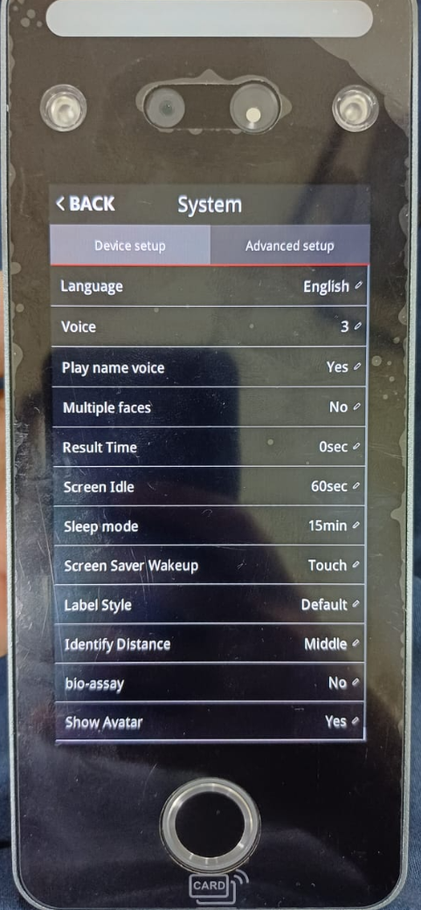 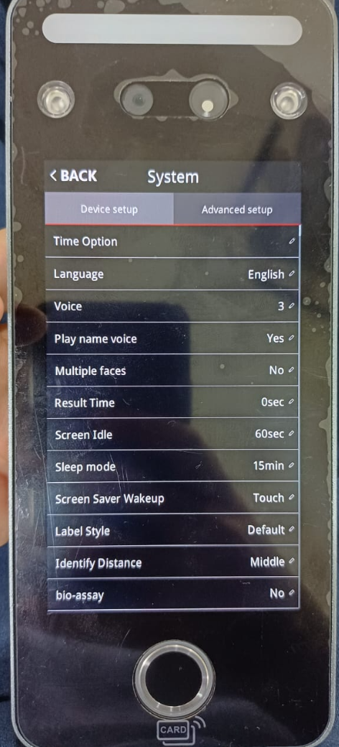\

Advanced Setup
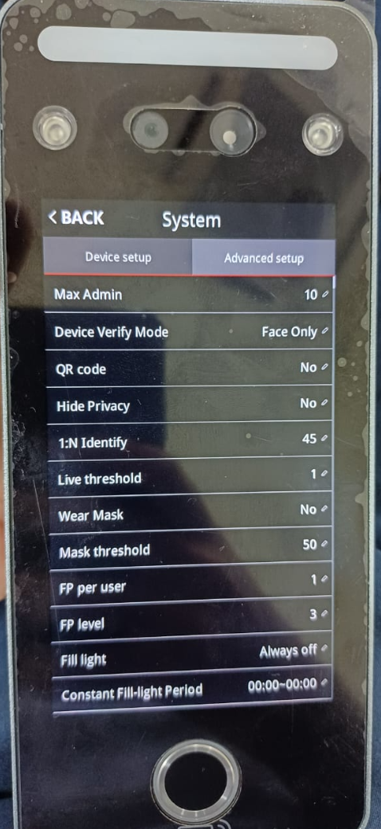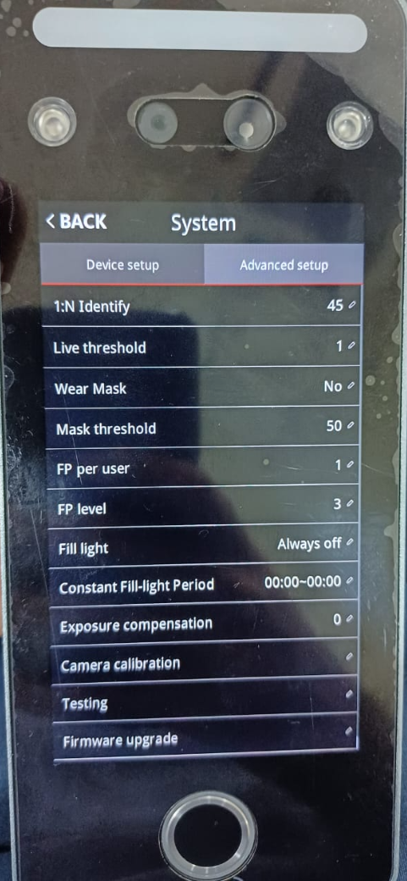

Access:
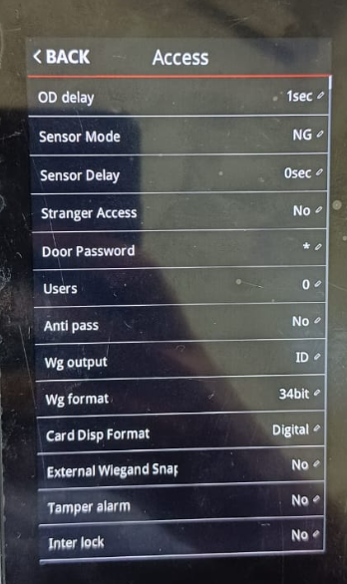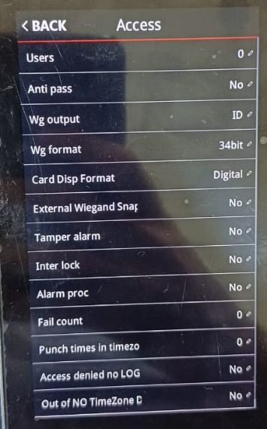

Shift:
